Cover page
Journal Section |  | N° Authors
Typeo of manuscript
Title in English
Title in Spanish
Main author | First Name & Last Name
Preferred Article Publication Name
(if it is different from above)
ORCID Code
Institutional Affiliation
Role in the Research According to CRediT
(see at the end)
(Only if there are two or more authors)
Brief Biography
(maximum 5 lines)
Email
Nacionality
Contact Phone Number (Corresponding author)
 | Repeat the data for each author.
Figures, Diagrams, Photos, or other Similar Materials | Include the information regarding authorizations and permissions for publication.
Use of Database or other Similar Sources | Include the information regarding authorizations and permissions obtained for their use.
Previous work | If the text is based on any previous work by the author (thesis, report, etc.), please indicate the source and what substantial changes have been made.
Potential Reviewers for Peer Review | Suggest 2 or 3 potential reviewers who could assess the manuscript, including their contact information (they should not have prior knowledge of the manuscript).
Before submitting the manuscript, verify that none of the authors' names appear anywhere. (Here are guidelines for anonymizing the files).. (Here are guidelines for anonymizing the files).

Author 2 | First Name & Last Name
Preferred Article Publication Name
(if it is different from above)
ORCID Code
Institutional Affiliation
Role in the Research According to CRediT
(see at the end)
(Only if there are two or more authors)
Brief Biography
(maximum 5 lines)
Email
Nacionality
Contact Phone Number (Corresponding author)
 | Repeat the data for each author.
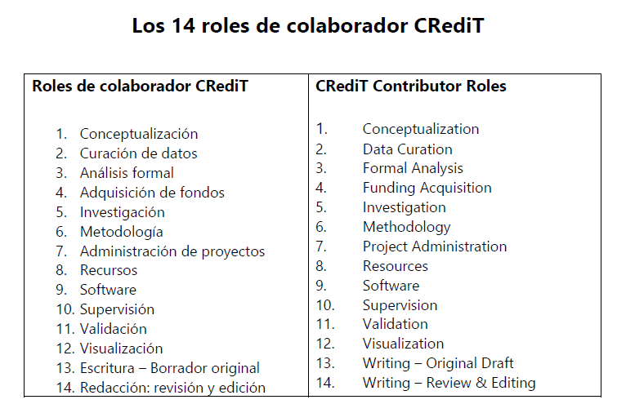
Fuente: CRediT (Contributor Roles Taxonomy). Elaboración propia.

